**ATAR Year 12 HUMAN BIOLOGY**

## **Inquiry 1 – Unit 3**

ANSWER KEY

**Assessment type:** Science Inquiry

**Validation**

## **Investigation of temperature regulation mechanisms of the human body**

The following mean data is taken from an experiment involving ten male recruits (18 to 19 years old) from the Singapore Armed Forces. Subjects performed a 12km march carrying a 28kg load under an ambient temperature of 30 degrees Celsius, where gastrointestinal temperature readings were recorded every 5 minutes for 170 minutes. The march was performed over 3 x 45 minutes of work intervals and was interspersed with a 15 min and 30 min rest interval after the first and second work intervals, respectively. Core temperature was measured using the ingestible telemetric temperature sensor that was ingested about 8 hours before the march.

**Results:**

|  |  |  |  |
| --- | --- | --- | --- |
| **Time (mins)** | **GI Temp (deg C)** | **Time (mins)** | **GI Temp (deg C)** |
| 0 | 37.5 |  |  |
| 5 | 37.6 | 90 | 38.5 |
| 10 | 37.8 | 95 | 38.7 |
| 15 | 37.9 | 100 | 38.8 |
| 20 | 37.9 | 105 | 39 |
| 25 | 38.1 | 110 | 39 |
| 30 | 38.2 | 115 | 38.7 |
| 35 | 38.3 | 120 | 38.5 |
| 40 | 38.4 | 125 | 38.4 |
| 45 | 38.4 | 130 | 38.3 |
| 50 | 38.3 | 135 | 38.3 |
| 55 | 38.1 | 140 | 38.4 |
| 60 | 38 | 145 | 38.5 |
| 65 | 38.1 | 150 | 38.5 |
| 70 | 38.2 | 155 | 38.8 |
| 75 | 38.3 | 160 | 39 |
| 80 | 38.4 | 165 | 39.2 |
| 85 | 38.4 | 170 | 39.4 |

**ATAR Year 12 HUMAN BIOLOGY**

## **Inquiry 1 – Unit 3**

1. Graph the above data (6 marks)

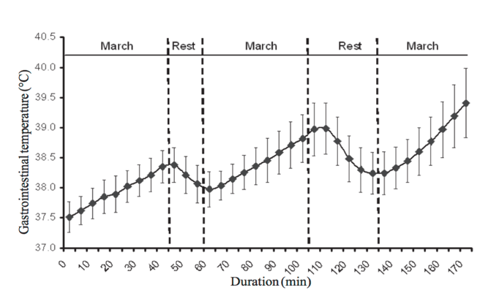

**Graph should be something similar to above.**

**Title – with independent and dependent variable (1)**

**Axes – Labels and units (1)**

* **Appropriate scale (2)**

**Accurate plotting (1)**

**Identified periods of marching and rest (1)**

1. Describe the changes that occur to the gastrointestinal temperatures of the soldiers during their march.

* GI temp increases with exertion from exercise (uses data to support answer)
* GI temp drops during period of rest (recovery rate of X degrees)
* GI temp continues to rise from periods of rest, recovery does not fully return body to starting temp during exertion.

(3 marks)

1. Account for the changes that occur to the gastrointestinal temperature of the soldiers during rest.

* Exercise increases BMR/Metabolism(1)
* By-product is heat (1)
* Explains using thermoregulation feedback (2)

(4 marks)

1. Explain the changes that would be evident at the surface of the body?

* Vasoldilation: Face would flush with increased blood flow to skin in attempt to increase radiation & evaporative heat loss (2 marks)
* Sweating: Sweat glands increase production of sweat to increase evaporative heat loss (2 marks)

(4 marks)

1. Propose how the data would change if the soldiers were marching in a subzero ambient temperature.

* Core body temp would begin slightly lower
* Rate of increase would be more gradual
* Temperature would still increase due to exertion

(3 marks)

1. Compare the methods of data collection seen in this experiment with your own experimental design. Which methods are most reliable and why?

* Comments on the reliability and accuracy of two experiments (1)
* Identifies two limitations in the data collection strategy (2)
* Comments on how it would/could have affected it (2)

(5 marks)